**A PROJECT REPORT**

on

**TOURISM MANAGEMENT SYSTEM**

***Submitted in partial fulfillment of the***

***requirement for the award of the degree of***

Bachelor of Computer Applications



**Under The Supervision of**

**MR. Arjun KP**

**ASSISTANT PROFESSOR**

**Department of Computer Science and Engineering**

Submitted By

PROJECT ID-BCA3051

RAHUL MISHRA 19SCSE1040103

RAJNISH PAL 19SCSE1040115

**SCHOOL OF COMPUTING SCIENCE AND ENGINEERING DEPARTMENT OF COMPUTER SCIENCE AND ENGINEERING**

**GALGOTIAS UNIVERSITY, GREATER NOIDA**

**INDIA**

**DECEMBER,2021**

**SCHOOL OF COMPUTING SCIENCE AND ENGINEERING**

**GALGOTIAS UNIVERSITY, GREATER NOIDA**

# CANDIDATE’S DECLARATION

I/We hereby certify that the work which is being presented in the thesis/project/dissertation, entitled **“TOURISM MANAGEMENT SYSTEM”** in partial fulfillment of the requirements for the award of the **Bachelors of Technology in Computer Science and Engineering**  submitted in the School of Computing Science and Engineering of Galgotias University, Greater Noida, is an original work carried out during the period of **July-2021 to December-2021**, under the supervision of **Mr. Arjun Kp , Assistant Professor , Department of Computer Science and Engineering** of School of Computing Science and Engineering , Galgotias University, Greater Noida

The matter presented in the thesis/project/dissertation has not been submitted by me/us for the award of any other degree of this or any other places.

Rahul Mishra,19SCSE1040103

Rajnish Pal,19SCSE1040115

This is to certify that the above statement made by the candidates is correct to the best of my knowledge.

Supervisor

(Mr. Arjun KP, Assistant Professor)

**CERTIFICATE**

The Final Thesis/Project/ Dissertation Viva-Voce examination of Rahul Mishra 19SCSE1040103 and Rajnish Pal,19SCSE1040115 has been held on _________________ and his/her work is recommended for the award Of BCA.

**Signature of Examiner(s) Signature of Supervisor(s)**

**Signature of Project Coordinator Signature of Dean**

Date:

Place:

**ACKNOWLEDGEMENT**

The feeling of gratitude when we expressed a holy acknowledgement and it’s with deep sense of gratitude that we acknowledge the able guidance.

We express our grateful thanks to Mr. Arjun K P, Associate professor, Department of Computer Science and Engineering, Galgotias University for providing us an opportunity for the research report on “**TOURISM MANAGEMENT SYSTEM**” and for his keen interest and the encouragement, which was required for the fulfilment of our capstone project report. We would also like to thank him for giving us valuable guidance at all levels, help and suggestions, which prove to be valuable for preparation of the report.

Finally, I would also like to thank all our friends for their cooperation and interest, which was necessary for completing our project report.

Date:

Rahul Mishra & Rajnish Pal

School of Computing Science & Engineering,

Galgotias University,

Greater Noida, Uttar Pradesh

**ABSTRACT**

The main objective of the Tourism Management System is to manage the details of Customer, Hotel Booking, Cancellation and Tourism places. It manages all the information about Users, Hotel, Packages etc. The project is totally built at administrative end and thus only the administrator is guaranteed the access to the backend database. The purpose of this project is to build an application program to reduce the manual work for managing Tourists, Booking, Places etc.

• This application will help in accessing the information related to the travel to the particular destination with great ease. The users can track the information related to their tours with great ease through this application. The travel agency information can also be obtained through this application.

• Through this system, the propose system is highly automated and makes the travelling activities much easier and flexible. The user can get the very right information at the very right time. This system will include all the necessary fields which are required during online reservation time. This system will be easy to use and can be used by any person. The basic idea behind this project is to save data in a central database which can be accessed by any authorize person to get information and saves time and burden which are being faced by their customers.

• Administrator can access and modify the information stored in the database of this system, this includes adding and updating of details, and it will give accurate information and simplifies manual work and also it minimizes the documentation related work. Provides up to date information. Finally booking confirmation notification will be send to the users.

**Table Of Contents**

|  |  |  |  |  |  |  |  |  |
| --- | --- | --- | --- | --- | --- | --- | --- | --- |
| **Title** | |  | | | | | | **Page No.** |
| **Candidates Declaration** | | | | | | | | **I** |
| **Acknowledgement** | | | | | | | | **II** |
| **Abstract** | | | | | | | | **III** |
| **Contents** | | | | | | | | **IV** |
| **List of Table** | | | | | | | | **V** |
| **List of Figures** | | | | | | | | **VI** |
| **Acronyms** | | | | | | | | **VII** |
| **Chapter 1** | **Introduction** | | | | | | | **1** |
|  | 1.1 | | General Introduction | | | | | **1** |
|  | 1.2 | | Formulation of Problem | | | | | **2** |
|  |  | | 1.2.1 | | | Tool and Technology Used | | **3-4** |
| **Chapter 2** | **Literature Survey** | | | | | | | **5** |
|  |  | |  | | |  | |  |
|  |  | |  | | |  | |  |
| **Chapter 3** | **Requirement Analysis**  3.1 Functionality/Working of Project  3.2 Software Requirements  3.3 Hardware Requirements | | | | | | | **6**  **6**  **7**  **7** |
|  |  | |  | | |  | |  |
|  |  | |  | | |  | | **8** |
| **Chapter 4** | **Project Design**  4.1 Introduction  4.2 Schema Diagram  4.3 ER Diagram  4.4 Source Code | | | | | | | **8**  **9**  **10**  **11-20** |
| **Chapter 5** | **Implementation & Testing**  5.1 Implementation  5.2 Testing | | | | | | | **21**  **21-22**  **23** |
|  |  | | |  | |  | |  |
| **Chapter 6** | **Working of Project and Results** | | | |  | |  | **23-30** |
| **Chapter 7** | **Conclusion and Future Scope** | | | | | | | **31** |
|  | 7.1 | | Conclusion | | | | |  |
|  | 7.2 | | Future Scope | | | | |  |
|  | **Reference** | | | | | | | **32** |
|  |  | | | | | | |  |
|  |  | |  | | |  | |  |

**CHAPTER-1**

**INTRODUCTION**

**1.1 General Introduction**

System design is the process of defining the elements of a system such as the architecture, modules and components, the different interfaces of those components and the data that goes through that system. It is meant to satisfy specific needs and requirements of a business or organization through the engineering of a coherent and well-running system.

System designing in terms of software engineering has its own value and importance in the system development process as a whole. To mention it may though seem as simple as anything or simply the design of systems, but in a broader sense it implies a systematic and rigorous approach to design such a system which fulfils all the practical aspects including flexibility, efficiency and security.

Before there is any further discussion of system design, it is important that some points be made clear. As it goes without saying that nothing is created that is not affected by the world in which it’s made. So, the systems are not created in a vacuum.

They are created in order to meet the needs of the users. They are not only intended to solve the existing problems, but they also come up with acceptable solutions to the problems that may arise in the future. The whole process of system development, from blueprint to the actual product, involves considering all the relevant factors and taking the required specifications and creating a useful system based on strong technical, analytical and development skills of the professionals.

Let’s get back to our discussion about what the system design phase is and the importance of system design in the process of system development. Being another important step in the system development process, system designing phase commences after the system analysis phase is completed. It’s appropriate to mention that the output or the specifications taken through the phase of system analysis become an input in the system design phase which in turn leads to workout based on the user defined estimations.

The importance of this phase may be understood by reason of the fact that it involves identifying data sources, the

nature and type of data that is available. For example, in order to design a salary system, there is a need for using

inputs, such as, attendance, leave details, additions or deductions etc. This facilitates understanding what kind of

data is available and by whom it is supplied to the system so that the system may be designed considering all the

relevant factors. In addition, system designing leads to ensure that the system is created in such a way that it fulfils

the need of the users and keep them at ease being user-oriented.

**1.2 Formulation of Problem**

**TRIGGERS:**

A trigger is a named database object that is associated with a table, and that activates when a particular event occurs for the table. Some uses for triggers are to perform checks of values to be inserted into a table or to perform calculations on values involved in an update.

A trigger is defined to activate when a statement inserts, updates, or deletes rows in the associated table. These row operations are trigger events. A trigger can be set to activate either before or after the trigger event. For example, you can have a trigger activate before each row that is inserted into a table or after each row that is updated.

**Trigger used in this application:**

create trigger `trigger_on_login` after insert on `customer` for each row insert into users(username,id,id_number,name,country,gender,address,phone,email)

values(NEW.username,NEW.id,NEW.id_number,NEW.name,NEW.country,NEW.gender,

NEW.address,NEW.phone,NEW.email);

**STORED PROCEDURE**:

A stored procedure is a prepared SQL code that you can save, so the code can be reused over and over again. So, if you have an SQL query that you write over and over again, save it as a stored procedure, and then just call it to execute it. You can also pass parameters to a stored procedure, so that the stored procedure can act based on the parameter value(s) that is passed.

The most important part is parameters. Parameters are used to pass values to the Procedure. There are 3 different types of parameters, they are as follows:

* **IN:**  This is the Default Parameter for the procedure. It always receives the values from calling program.
* **OUT:** This parameter always sends the values to the calling program.
* **IN OUT:** This parameter performs both the operations. It Receives value from as well as sends the values to the calling program.

**Stored Procedure used in above application:**

To select all the data from customer table:

DELIMITER$$

CREATE DEFINER=`root`@`localhost` PROCEDURE `getCustomer*`*

BEGIN

SELECT * FROM CUSTOMER;

END;

DELIMITER;

**1.2.1 Tool and Technology Used**

**A. JAVA**

Java is a programming language created by James Gosling from Sun Microsystems (Sun) in 1991. The target of Java is to write a program once and then run this program on multiple operating systems. The first publicly available version of Java (Java 1.0) was released in 1995. Sun Microsystems was acquired by the Oracle Corporation in 2010. Oracle has now the steer Manship for Java. In 2006 Sun started to make Java available under the GNU General Public License (GPL). Oracle continues this project called OpenJDK.

Over time new enhanced versions of Java have been released. The current version of Java is Java 1.8 which is also known as Java 8.

Java is defined by a specification and consists of a programming language, a compiler, core libraries and a runtime (Java virtual machine) The Java runtime allows software developers to write program code in other languages than the Java programming language which still runs on the Java virtual machine. The Javaplatformis usually associated with the Java virtual machineand the Java corelibraries.

**B. Java Database Connectivity** (**JDBC**)

Is an application programming interface (API) for the programming language Java, which defines how a client may access a database. It is Java based data access technology and used for Java database connectivity. It is part of the Java Standard Edition platform, from Oracle Corporation. It provides methods to query and update data in a database, and is oriented towards relational databases.

**C. SQL**

Is a language to operate database; it includes database creation, deletion, fetching rows, modifying rows, etc. SQL is an ANSI (American National Standards Institute) standard language, but there are many different versions of SQL language. SQL is a Structured Query Language, which is a computer language for storing, manipulating and retrieving data stored in a relation database.

SQL is the standard language for Relational Database System. All the Relation Database Management System (RDBMS) like My SQL, MS Access, Oracle, Sybase, Informix, Postgres and SQL Server use SQL as their standard database language.

**Why SQL?**

SQL is widely popular because it offers the following advantages:

* Allows user to access data in the RDBMS.
* Allows the user to describe the data.
* Allows user to create and drop database and table.
* Allows user to set permission on table, procedures and views.
* Allows user to create view, stored procedure, function in a database.

Allows user to define data in a database and manipulate that data.

* Allows to embed within other language using SQL modules, libraries and pre-compilers

**CHAPTER-2**

**LITRATURE SURVEY**

The process of the system we can consider here, can maintain the databases of the system. We can insert to the databases and retrieve all the information.

The main aim of this project is to help the tourists to manage their trip. It makes all operation of the tour company easy and accurate. The standalone platform makes tourism management easy by handling requests and providing servers for the customers located at different parts of the various

cities. Different modules have been incorporated in this project to handle different parts and sector of the tour management field.

**CHAPTER 3**

**Requirement Analysis**

**3.1 Functionality/Working of Project**

**GRAPHICAL USER INTERFACES**

A graphical user interface (GUI) is a type of interface that allows users to interact with electronic devices or programs through graphical icons and visual indicators such as secondary notation, as opposed to text-based interfaces, typed command labels or text navigation. GUIs are easier to learn than command-line interfaces (CLIs), which require commands to be typed on the keyboard.

Third-party proprietary and free graphical administration applications (or "front ends") are available that integrate with MySQL and enable users to work with database structure and data visually. Some well-known front ends are:

MySQL Workbench

MySQL Workbench is the official integrated environment for MySQL. It was developed by MySQL AB, and enables users to graphically administer MySQL databases and visually design database structures. MySQL Workbench replaces the previous package of software, MySQL

GUI Tools. Similar to other third-party packages, but still considered the authoritative MySQL front end, MySQL Workbench lets users manage database design & modelling, SQL development (replacing MySQL Query Browser) and Database administration (replacing MySQL Administrator).

MySQL Workbench is available in two editions, the regular free and open source CommunityEditionwhich may be downloaded from the MySQL website, and the proprietary StandardEditionwhich extends and improves the feature set of the Community Edition.

**COMMAND LINE INTERFACES**

A command-line interface is a means of interacting with a computer program where the user issues commands to the program by typing in successive lines of text (command lines). MySQL ships with many command lines tools, from which the main interface is the MySQL client.

MySQL Utilities is a set of utilities designed to perform common maintenance and administrative tasks. Originally included as part of the MySQL Workbench, the utilities are a stand-alone download available from Oracle.

## 3.2 SOFTWARE SPECIFICATION

* Operating system: Microsoft windows 10.
* Integrated Development Environment: Netbeans
* MySQL Command Line Client
* Programming language: JAVA

## 3.3 HARDWARE SPECIFICATION

* System type: 64-bit Operating System, x64-bassed processor.
* Installed memory (RAM):8.00 GB (7.43 GB Usable)
* Total size of Hard disk: 1 TB

**Chapter 4 Project Design**

**4.1 INTRODUCTION**

System design is the process of defining the elements of a system such as the architecture, modules and components, the different interfaces of those components and the data that goes through that system. It is meant to satisfy specific needs and requirements of a business or organization through the engineering of a coherent and well-running system.

System designing in terms of software engineering has its own value and importance in the system development process as a whole. To mention it may though seem as simple as anything or simply the design of systems, but in a broader sense it implies a systematic and rigorous approach to design such a system which fulfils all the practical aspects including flexibility, efficiency and security.

Before there is any further discussion of system design, it is important that some points be made clear. As it goes without saying that nothing is created that is not affected by the world in which it’s made. So, the systems are not created in a vacuum.

They are created in order to meet the needs of the users. They are not only intended to solve the existing problems, but they also come up with acceptable solutions to the problems that may arise in the future. The whole process of system development, from blueprint to the actual product, involves considering all the relevant factors and taking the required specifications and creating a useful system based on strong technical, analytical and development skills of the professionals.

Let’s get back to our discussion about what the system design phase is and the importance of system design in the process of system development. Being another important step in the system development process, system designing phase commences after the system analysis phase is completed. It’s appropriate to mention that the output or the specifications taken through the phase of system analysis become an input in the system design phase which in turn leads to workout based on the user defined estimations.

The importance of this phase may be understood by reason of the fact that it involves identifying data sources, the nature and type of data that is available. For example, in order to design a salary system, there is a need for using inputs, such as, attendance, leave details, additions or deductions etc. This facilitates understanding what kind of data is available and by whom it is supplied to the system so that the system may be designed considering all the relevant factors. In addition, system designing leads to ensure that the system is created in such a way that it fulfils the need of the users and keep them at ease being user-oriented.

**4.2 SCHEMA DIAGRAM:**

A database schema is the skeleton structure that represents the logical view of the entire database. It defines how the data is organized and how the relations among them are associated. It formulates all the constraints that are to be applied on the data.

A database schema defines its entities and the relationship among them. It contains a descriptive detail of the database, which can be depicted by means of schema diagrams. It’s the database designers who design the schema to help programmers understand the database and make it useful.

Account:

|  |  |  |  |  |
| --- | --- | --- | --- | --- |
| username | name | Password | security | answer |

Customer:

|  |  |  |  |  |  |  |  |  |
| --- | --- | --- | --- | --- | --- | --- | --- | --- |
| username | id | id_number | name | gender | country | address | phone | Email |

Book package:

|  |  |  |  |  |  |  |
| --- | --- | --- | --- | --- | --- | --- |
| username | package | persons | id | id_number | phone | Price |

Book Hotel:

|  |  |  |  |  |  |  |  |  |  |
| --- | --- | --- | --- | --- | --- | --- | --- | --- | --- |
| username | hotel | Persons | days | Ac | food | id | id_number | phone | Price |

Hotel:

|  |  |  |  |
| --- | --- | --- | --- |
| Hotel | cost_per_day | food_charges | ac_charges |

**4.3 E R DIAGRAM:**

**ER Diagram** stands for Entity Relationship Diagram, also known as ERD is a diagram that displays the relationship of entity sets stored in a database. In other words, ER diagrams help to explain the logical structure of databases. ER diagrams are created based on three basic concepts: entities, attributes and relationships. ER Diagrams contain different symbols that use rectangles to represent entities, ovals to define attributes and diamond shapes to represent relationships.

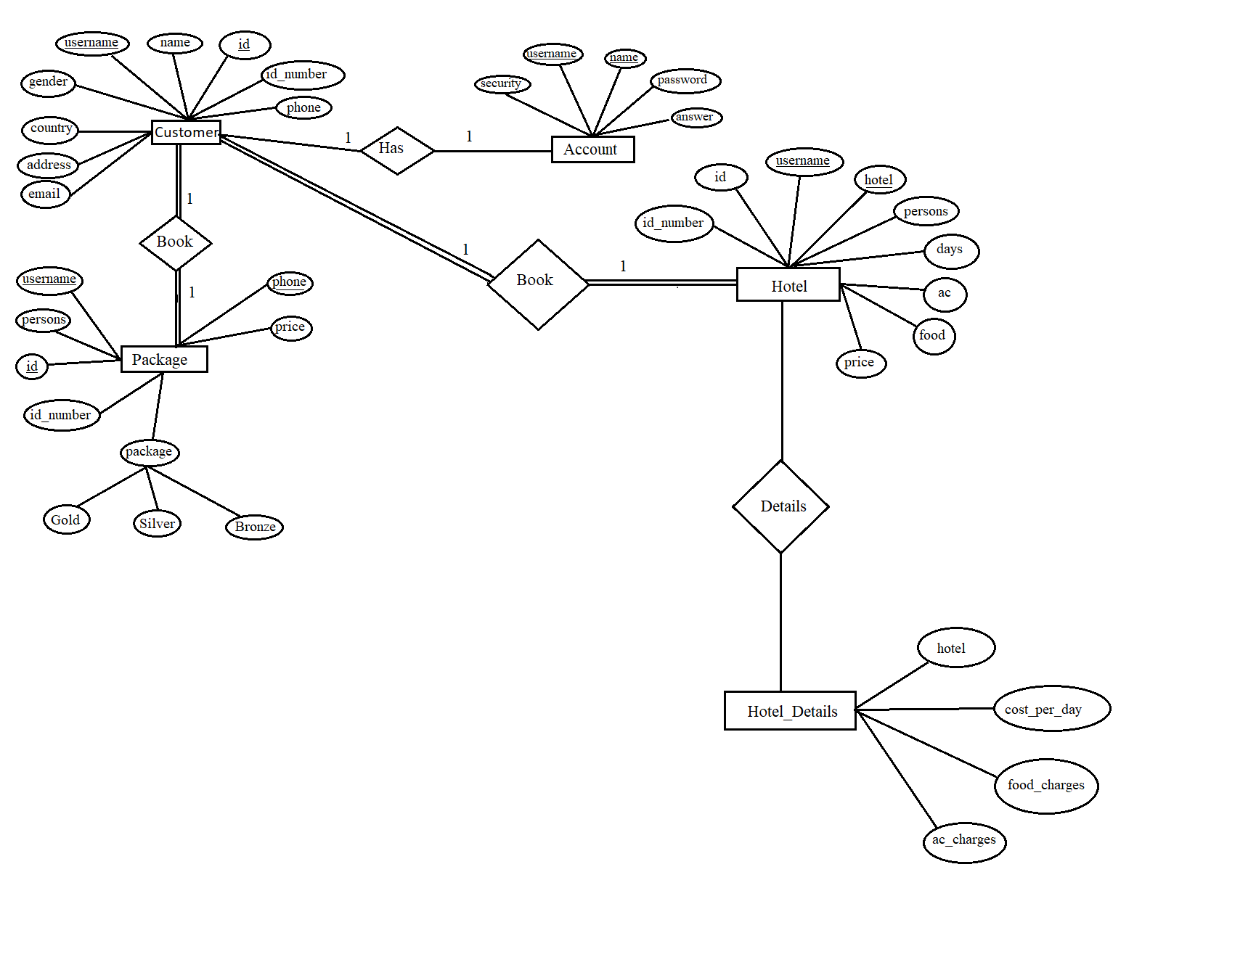4.3 The above figure represents the ER Diagram.

**Source Code**

**Splash.java**

**package tourismmanagementsystem;**

**import javax.swing.*;**

**import java.awt.*;**

**public class Splash {**

**public static void main(String[] args) {**

**SplashFrame frame=new SplashFrame();**

**frame.setVisible(true);**

**int x=1;**

**for (int i=1;i<=550;i+=9,x+=7) {**

**frame.setLocation(650-(x+i)/2,370-(i/2));**

**frame.setSize(x+i, i);**

**try{**

**Thread.sleep(10);**

**}catch (Exception e){**

**}**

**}**

**frame.setVisible(true);**

**}**

**}**

**class SplashFrame extends JFrame implements Runnable {**

**Thread t1;**

**SplashFrame() {**

**ImageIcon i1=new ImageIcon(ClassLoader.getSystemResource("tourismmanagementsystem/icons/splash.jpg"));**

**Image i2=i1.getImage().getScaledInstance(1000,550,Image.SCALE_DEFAULT);**

**ImageIcon i3=new ImageIcon(i2);**

**JLabel l1=new JLabel(i3);**

**add(l1);**

**setUndecorated(true);**

**t1=new Thread(this);**

**t1.start();**

**}**

**public void run() {**

**try {**

**Thread.sleep(5000);**

**this.setVisible(false);**

**new Login().setVisible(true);**

**} catch (Exception e) {**

**}**

**}**

**}**

**Login.java**

**package tourismmanagementsystem;**

**import javax.swing.*;**

**import javax.swing.border.*;**

**import java.awt.*;**

**import java.awt.event.ActionEvent;**

**import java.awt.event.ActionListener;**

**import java.sql.*;**

**public class Login extends JFrame implements ActionListener{**

**JButton b1,b2,b3;**

**JTextField t1;**

**JPasswordField t2;**

**Login(){**

**setBounds(220,130,900,400);**

**getContentPane().setBackground(Color.white);**

**setLayout(null);**

**JPanel p1=new JPanel();**

**p1.setBackground(new Color(131,193,233));**

**p1.setBounds(0,0,400,400);**

**p1.setLayout(null);**

**add(p1);**

**ImageIcon i1=new ImageIcon(ClassLoader.getSystemResource("tourismmanagementsystem/icons/login.png"));**

**Image i2=i1.getImage().getScaledInstance(200,200,Image.SCALE_DEFAULT);**

**ImageIcon i3=new ImageIcon(i2);**

**JLabel l1=new JLabel(i3);**

**l1.setBounds(100,80,200,200);**

**p1.add(l1);**

**JPanel p2=new JPanel();**

**p2.setBounds(400,30,460,300);**

**p2.setLayout(null);**

**add(p2);**

**JLabel l2=new JLabel("Username");**

**l2.setBounds(60,20,200,25);**

**l2.setFont(new Font("SAN_SERIF",Font.PLAIN,20));**

**p2.add(l2);**

**t1=new JTextField();**

**t1.setBounds(60,60,300,30);**

**t1.setBorder(BorderFactory.createEmptyBorder());**

**p2.add(t1);**

**JLabel l3=new JLabel("Password");**

**l3.setBounds(60,100,200,25);**

**l3.setFont(new Font("SAN_SERIF",Font.PLAIN,20));**

**p2.add(l3);**

**t2=new JPasswordField();**

**t2.setBounds(60,140,300,30);**

**t2.setBorder(BorderFactory.createEmptyBorder());**

**p2.add(t2);**

**b1=new JButton("Login");**

**b1.setFont(new Font("SAN_SERIF",Font.PLAIN,20));**

**b1.setBackground(new Color(131,193,233));**

**b1.setForeground(Color.white);**

**b1.setBorder(BorderFactory.createEmptyBorder());**

**b1.setBounds(60,200,150,30);**

**b1.addActionListener(this::actionPerformed);**

**p2.add(b1);**

**b2=new JButton("Signup");**

**b2.setFont(new Font("SAN_SERIF",Font.PLAIN,20));**

**b2.setForeground(new Color(131,193,233));**

**b2.setBackground(Color.white);**

**b2.setBorder(new LineBorder(new Color(131,193,233)));**

**b2.setBounds(230,200,150,30);**

**b2.addActionListener(this::actionPerformed);**

**p2.add(b2);**

**b3=new JButton("Forget Password");**

**b3.setFont(new Font("SAN_SERIF",Font.PLAIN,20));**

**b3.setForeground(new Color(131,193,233));**

**b3.setBackground(Color.white);**

**b3.setBorder(new LineBorder(new Color(131,193,233)));**

**b3.setBounds(130,250,200,30);**

**b3.addActionListener(this::actionPerformed);**

**p2.add(b3);**

**JLabel l4=new JLabel("Trouble in Login...");**

**l4.setForeground(Color.RED);**

**l4.setBounds(340,250,150,20);**

**p2.add(l4);**

**// setUndecorated(true);**

**setVisible(true);**

**}**

**public void actionPerformed(ActionEvent ae) {**

**if (ae.getSource() == b1) {**

**try{**

**String username=t1.getText();**

**String password=t2.getText();**

**String sql="Select * from accounts where username = '"+username+"' And password = '"+password+"'";**

**Conn c=new Conn();**

**ResultSet rs=c.s.executeQuery(sql);**

**if(rs.next()){**

**this.setVisible(false);**

**new Loading(username).setVisible(true);**

**}else{**

**JOptionPane.showMessageDialog(null,"Invalid Login");**

**}**

**}catch(Exception e){}**

**}else if (ae.getSource() == b2)**

**{**

**this.setVisible(false);**

**new Signup().setVisible(true);**

**}**

**else if(ae.getSource() == b3)**

**{**

**this.setVisible(false);**

**new ForgetPassword().setVisible(true);**

**}**

**}**

**public static void main(String args[]){**

**new Login();**

**}**

**}**

**Loading.java**

**package tourismmanagementsystem;**

**import java.awt.*;**

**import javax.swing.*;**

**public class Loading extends JFrame implements Runnable{**

**JProgressBar p;**

**Thread t;**

**String username;**

**public void run(){**

**try{**

**for(int i=1;i<=101;i++){**

**int m=p.getMaximum();**

**int n=p.getValue();**

**if(n<m){**

**p.setValue(p.getValue() + 1);**

**}**

**else{**

**i=101;**

**setVisible(false);**

**new Dashboard(username).setVisible(true);**

**}**

**Thread.sleep(50);**

**}**

**}**

**catch(Exception e){**

**}**

**}**

**Loading(String user){**

**username=user;**

**t=new Thread(this);**

**setBounds(400,150,500,400);**

**getContentPane().setBackground(Color.WHITE);**

**setLayout(null);**

**JLabel l1=new JLabel("Travel And Tourism Application");**

**l1.setBounds(50,20,600,40);**

**l1.setFont(new Font("Raleway",Font.BOLD,25));**

**l1.setForeground(Color.blue);**

**add(l1);**

**p= new JProgressBar();**

**p.setStringPainted(true);**

**p.setBounds(100,80,300,25);**

**add(p);**

**JLabel l2=new JLabel("Please Wait...");**

**l2.setBounds(200,110,100,25);**

**l2.setFont(new Font("Tahoma",Font.BOLD,14));**

**l2.setForeground(Color.red);**

**add(l2);**

**JLabel l3=new JLabel("Welcome " + username);**

**l3.setBounds(20,320,600,25);**

**l3.setFont(new Font("Tahoma",Font.BOLD,16));**

**l3.setForeground(Color.red);**

**add(l3);**

**t.start();**

**}**

**public static void main(String[] args) {**

**new Loading("").setVisible(true);**

**}**

**}**

**CheckHotels.java**

**package tourismmanagementsystem;**

**import javax.swing.*;**

**import java.awt.*;**

**public class CheckHotels extends JFrame implements Runnable{**

**Thread t1;**

**JLabel l1,l2,l3,l4,l5,l6,l7,l8,l9,l10;**

**JLabel[] label =new JLabel[]{l1,l2,l3,l4,l5,l6,l7,l8,l9,l10};**

**JLabel caption;**

**public void run(){**

**String[] text =new String[]{"Jw Marriott Hotel","Mandarin Oriental Hotel","Four Seasons Hotel","Radisson Hotel","Classio Hotel","The Bay Club Hotel","Breeze Blows Hotel","Quick Stop Hotel","Quick Stop Hotel","Happy Mornings Motel","Moss View Hotel"};**

**try{**

**for(int i=0;i<=9;i++){**

**this.label[i].setVisible(true);**

**caption.setText(text[i]);**

**this.label[i].add(caption);**

**Thread.sleep(2800);**

**this.label[i].setVisible(false);**

**}**

**}catch(Exception e){**

**}**

**}**

**CheckHotels(){**

**setBounds(250,75,700,550);**

**ImageIcon i1=null,i2=null,i3=null,i4=null,i5=null,i6=null,i7=null,i8=null,i9=null,i10=null;**

**ImageIcon[] image=new ImageIcon[]{i1,i2,i3,i4,i5,i6,i7,i8,i9,i10};**

**Image j1=null,j2=null,j3=null,j4=null,j5=null,j6=null,j7=null,j8=null,j9=null,j10=null;**

**Image[] jimage=new Image[]{j1,j2,j3,j4,j5,j6,j7,j8,j9,j10};**

**ImageIcon i11=null,i12=null,i13=null,i14=null,i15=null,i16=null,i17=null,i18=null,i19=null,i20=null;**

**ImageIcon[] iimage=new ImageIcon[]{i11,i12,i13,i14,i15,i16,i17,i18,i19,i20};**

**caption=new JLabel();**

**caption.setBounds(50,420,1000,70);**

**caption.setForeground(Color.WHITE);**

**caption.setFont(new Font("Tahoma", Font.PLAIN,30));**

**for(int i=0;i<=9;i++){**

**image[i]=new ImageIcon(ClassLoader.getSystemResource("tourismmanagementsystem/icons/hotel"+(i+1)+".jpg"));**

**jimage[i]=image[i].getImage().getScaledInstance(700,550,Image.SCALE_DEFAULT);**

**iimage[i]=new ImageIcon(jimage[i]);**

**this.label[i]=new JLabel(iimage[i]);**

**this.label[i].setBounds(0,0,700,550);**

**add(this.label[i]);**

**}**

**t1=new Thread(this);**

**t1.start();**

**}**

**public static void main(String[] args) {**

**new CheckHotels().setVisible(true);**

**}**

**}**

**Dashboard.java**

**package tourismmanagementsystem;**

**import javax.swing.*;**

**import java.awt.*;**

**import java.awt.event.*;**

**public class Dashboard extends JFrame implements ActionListener{**

**JButton b1,b2,b3,b4,b5,b6,b7,b8,b9,b10,b11,b12,b13,b14;**

**String username;**

**Dashboard(String username){**

**this.username=username;**

**setExtendedState(JFrame.MAXIMIZED_BOTH);**

**setLayout(null);**

**JPanel p1=new JPanel();**

**p1.setBounds(0,0,1950,65);**

**p1.setLayout(null);**

**p1.setBackground(new Color(0,0,102));**

**add(p1);**

**JPanel p2=new JPanel();**

**p2.setBounds(0,65,250,1000);**

**p2.setLayout(null);**

**p2.setBackground(new Color(0,0,102));**

**add(p2);**

**b1=new JButton("Add Personal Details");**

**b1.setBackground(new Color(0,0,102));**

**b1.setFont(new Font("Tahoma",Font.PLAIN,15));**

**b1.setForeground(Color.white);**

**b1.setMargin(new Insets(0,0,0,80));**

**b1.setBounds(0,0,250,35);**

**b1.addActionListener(this);**

**p2.add(b1);**

**b2=new JButton("Update Personal Details");**

**b2.setBackground(new Color(0,0,102));**

**b2.setFont(new Font("Tahoma",Font.PLAIN,15));**

**b2.setForeground(Color.white);**

**b2.setMargin(new Insets(0,0,0,60));**

**b2.setBounds(0,30,250,35);**

**b2.addActionListener(this);**

**p2.add(b2);**

**b3=new JButton("View Details");**

**b3.setBackground(new Color(0,0,102));**

**b3.setFont(new Font("Tahoma",Font.PLAIN,15));**

**b3.setForeground(Color.white);**

**b3.setMargin(new Insets(0,0,0,135));**

**b3.setBounds(0,60,250,35);**

**b3.addActionListener(this);**

**p2.add(b3);**

**b4=new JButton("Delete Personal Details");**

**b4.setBackground(new Color(0,0,102));**

**b4.setFont(new Font("Tahoma",Font.PLAIN,15));**

**b4.setForeground(Color.white);**

**b4.setMargin(new Insets(0,0,0,65));**

**b4.setBounds(0,90,250,35);**

**p2.add(b4);**

**b5=new JButton("Check Package");**

**b5.setBackground(new Color(0,0,102));**

**b5.setFont(new Font("Tahoma",Font.PLAIN,15));**

**b5.setForeground(Color.white);**

**b5.setMargin(new Insets(0,0,0,120));**

**b5.setBounds(0,120,250,35);**

**b5.addActionListener(this);**

**p2.add(b5);**

**b6=new JButton("Book Package");**

**b6.setBackground(new Color(0,0,102));**

**b6.setFont(new Font("Tahoma",Font.PLAIN,15));**

**b6.setForeground(Color.white);**

**b6.setMargin(new Insets(0,0,0,125));**

**b6.setBounds(0,150,250,35);**

**b6.addActionListener(this);**

**p2.add(b6);**

**b7=new JButton("View Package");**

**b7.setBackground(new Color(0,0,102));**

**b7.setFont(new Font("Tahoma",Font.PLAIN,15));**

**b7.setForeground(Color.white);**

**b7.setMargin(new Insets(0,0,0,125));**

**b7.setBounds(0,180,250,35);**

**b7.addActionListener(this);**

**p2.add(b7);**

**b8=new JButton("View Hotels");**

**b8.setBackground(new Color(0,0,102));**

**b8.setFont(new Font("Tahoma",Font.PLAIN,15));**

**b8.setForeground(Color.white);**

**b8.setMargin(new Insets(0,0,0,140));**

**b8.setBounds(0,210,250,35);**

**b8.addActionListener(this);**

**p2.add(b8);**

**b9=new JButton("Book Hotel");**

**b9.setBackground(new Color(0,0,102));**

**b9.setFont(new Font("Tahoma",Font.PLAIN,15));**

**b9.setForeground(Color.white);**

**b9.setMargin(new Insets(0,0,0,145));**

**b9.setBounds(0,240,250,35);**

**b9.addActionListener(this);**

**p2.add(b9);**

**b10=new JButton("View Booked Hotel");**

**b10.setBackground(new Color(0,0,102));**

**b10.setFont(new Font("Tahoma",Font.PLAIN,15));**

**b10.setForeground(Color.white);**

**b10.setMargin(new Insets(0,0,0,90));**

**b10.setBounds(0,270,250,35);**

**b10.addActionListener(this);**

**p2.add(b10);**

**b11=new JButton("Destinations");**

**b11.setBackground(new Color(0,0,102));**

**b11.setFont(new Font("Tahoma",Font.PLAIN,15));**

**b11.setForeground(Color.white);**

**b11.setMargin(new Insets(0,0,0,130));**

**b11.setBounds(0,300,250,35);**

**b11.addActionListener(this);**

**p2.add(b11);**

**b12=new JButton("Payment");**

**b12.setBackground(new Color(0,0,102));**

**b12.setFont(new Font("Tahoma",Font.PLAIN,15));**

**b12.setForeground(Color.white);**

**b12.setMargin(new Insets(0,0,0,155));**

**b12.setBounds(0,330,250,35);**

**p2.add(b12);**

**b13=new JButton("Calculator");**

**b13.setBackground(new Color(0,0,102));**

**b13.setFont(new Font("Tahoma",Font.PLAIN,15));**

**b13.setForeground(Color.white);**

**b13.setMargin(new Insets(0,0,0,150));**

**b13.setBounds(0,360,250,35);**

**b13.addActionListener(this);**

**p2.add(b13);**

**b14=new JButton("Notepad");**

**b14.setBackground(new Color(0,0,102));**

**b14.setFont(new Font("Tahoma",Font.PLAIN,15));**

**b14.setForeground(Color.white);**

**b14.setMargin(new Insets(0,0,0,155));**

**b14.setBounds(0,390,250,35);**

**b14.addActionListener(this);**

**p2.add(b14);**

**JButton b15=new JButton("About");**

**b15.setBackground(new Color(0,0,102));**

**b15.setFont(new Font("Tahoma",Font.PLAIN,15));**

**b15.setForeground(Color.white);**

**b15.setMargin(new Insets(0,0,0,165));**

**b15.setBounds(0,420,250,35);**

**p2.add(b15);**

**ImageIcon i4=new ImageIcon(ClassLoader.getSystemResource("tourismmanagementsystem/icons/dash.png"));**

**Image i5 =i4.getImage().getScaledInstance(70,70,Image.SCALE_DEFAULT);**

**ImageIcon i6=new ImageIcon(i5);**

**JLabel l2=new JLabel(i6);**

**l2.setBounds(0,0,70,70);**

**p1.add(l2);**

**JLabel l3=new JLabel("Dashboard");**

**l3.setFont(new Font("Tahome",Font.BOLD,30));**

**l3.setForeground(Color.white);**

**l3.setBounds(80,10,300,40);**

**p1.add(l3);**

**ImageIcon i1=new ImageIcon(ClassLoader.getSystemResource("tourismmanagementsystem/icons/home.jpg"));**

**Image i2 =i1.getImage().getScaledInstance(1950,1000,Image.SCALE_DEFAULT);**

**ImageIcon i3=new ImageIcon(i2);**

**JLabel l1=new JLabel(i3);**

**l1.setBounds(0,0,1950,1000);**

**add(l1);**

**JLabel l4=new JLabel("Travel And Tourism Management System");**

**l4.setBounds(400,80,1000,60);**

**l4.setForeground(Color.white);**

**l4.setFont(new Font("Tahoma",Font.PLAIN,40));**

**l1.add(l4);**

**}**

**public void actionPerformed(ActionEvent ae){**

**if(ae.getSource()==b13){**

**try{**

**Runtime.getRuntime().exec("calc.exe");**

**}catch(Exception e){**

**}**

**}else if(ae.getSource()==b14){**

**try{**

**Runtime.getRuntime().exec("notepad.exe");**

**}catch(Exception e){**

**}**

**}else if(ae.getSource()==b1){**

**new AddCustomer(username).setVisible(true);**

**}else if(ae.getSource()==b2){**

**new UpdateCustomer(username).setVisible(true);**

**}**

**else if(ae.getSource()==b3){**

**new ViewCustomer(username).setVisible(true);**

**}else if(ae.getSource()==b5){**

**new CheckPackage().setVisible(true);**

**}else if(ae.getSource()==b6){**

**new BookPackage(username).setVisible(true);**

**}else if(ae.getSource()==b7){**

**new ViewPackage(username).setVisible(true);**

**}else if(ae.getSource()==b8){**

**new CheckHotels().setVisible(true);**

**}else if(ae.getSource()==b11){**

**new Destination().setVisible(true);**

**}else if(ae.getSource()==b9){**

**new BookHotel(username).setVisible(true);**

**}else if(ae.getSource()==b10){**

**new ViewBookedHotel(username).setVisible(true);**

**}**

**}**

**public static void main(String[] args){**

**new Dashboard("").setVisible(true);**

**}**

**}**

**Destination.java**

**package tourismmanagementsystem;**

**import javax.swing.*;**

**import java.awt.*;**

**public class Destination extends JFrame implements Runnable{**

**Thread t1;**

**JLabel l1,l2,l3,l4,l5,l6,l7,l8,l9,l10;**

**JLabel[] label =new JLabel[]{l1,l2,l3,l4,l5,l6,l7,l8,l9,l10};**

**public void run(){**

**String[] text =new String[]{"Jw Marriott Hotel","Mandarin Oriental Hotel","Four Seasons Hotel","Radisson Hotel","Classio Hotel","The Bay Club Hotel","Breeze Blows Hotel","Quick Stop Hotel","Quick Stop Hotel","Happy Mornings Motel","Moss View Hotel"};**

**try{**

**for(int i=0;i<=9;i++){**

**this.label[i].setVisible(true);**

**Thread.sleep(2800);**

**this.label[i].setVisible(false);**

**}**

**}catch(Exception e){**

**}**

**}**

**Destination(){**

**setBounds(250,75,700,550);**

**ImageIcon i1=null,i2=null,i3=null,i4=null,i5=null,i6=null,i7=null,i8=null,i9=null,i10=null;**

**ImageIcon[] image=new ImageIcon[]{i1,i2,i3,i4,i5,i6,i7,i8,i9,i10};**

**Image j1=null,j2=null,j3=null,j4=null,j5=null,j6=null,j7=null,j8=null,j9=null,j10=null;**

**Image[] jimage=new Image[]{j1,j2,j3,j4,j5,j6,j7,j8,j9,j10};**

**ImageIcon i11=null,i12=null,i13=null,i14=null,i15=null,i16=null,i17=null,i18=null,i19=null,i20=null;**

**ImageIcon[] iimage=new ImageIcon[]{i11,i12,i13,i14,i15,i16,i17,i18,i19,i20};**

**for(int i=0;i<=9;i++){**

**image[i]=new ImageIcon(ClassLoader.getSystemResource("tourismmanagementsystem/icons/dest"+(i+1)+".jpg"));**

**jimage[i]=image[i].getImage().getScaledInstance(700,550,Image.SCALE_DEFAULT);**

**iimage[i]=new ImageIcon(jimage[i]);**

**this.label[i]=new JLabel(iimage[i]);**

**this.label[i].setBounds(0,0,700,550);**

**add(this.label[i]);**

**}**

**t1=new Thread(this);**

**t1.start();**

**}**

**public static void main(String[] args) {**

**new Destination().setVisible(true);**

**}**

**}**

**Conn.java**

**package tourismmanagementsystem;**

**import java.sql.*;**

**public class Conn {**

**Connection c;**

**Statement s;**

**public Conn(){**

**try{**

**Class.forName("com.mysql.jdbc.Driver");**

**c=DriverManager.getConnection("jdbc:mysql:///dms","root","root");**

**s=c.createStatement();**

**}**

**catch(Exception e){**

**}**

**}**

**}**

**Chapter 5**

**Implementation & Testing**

**5.1 IMPLEMENTATION**

**TABLE 5.1.1: ACCOUNT:**

|  |  |  |  |  |  |
| --- | --- | --- | --- | --- | --- |
| **Field** | **Type** | **Null** | **Key** | **Default** | **Extra** |
| Username | varchar(30) | NO | PRI | NULL |  |
| Name | varchar(30) | NO | PRI | NULL |  |
| Password | varchar(30) | NO |  | NULL |  |
| Security | varchar(30) | NO |  | NULL |  |
| Answer | varchar(30) | NO |  | NULL |  |

**TABLE 5.1.2: CUSTOMER:**

|  |  |  |  |  |  |
| --- | --- | --- | --- | --- | --- |
| **Field** | **Type** | **Null** | **Key** | **Default** | **Extra** |
| Username | varchar(30) | NO | MUL | NULL |  |
| Id | varchar(30) | NO | PRI | NULL |  |
| id_number | varchar(30) | NO |  | NULL |  |
| Name | varchar(30) | NO |  | NULL |  |
| Gender | varchar(30) | NO |  | NULL |  |
| Country | varchar(30) | NO |  | NULL |  |
| Address | varchar(30) | NO |  | NULL |  |
| Phone | varchar(30) | NO |  | NULL |  |
| Email | varchar(30) | NO |  | NULL |  |

**TABLE 5.1.3: BOOK PACKAGE:**

|  |  |  |  |  |  |
| --- | --- | --- | --- | --- | --- |
| **Field** | **Type** | **Null** | **Key** | **Default** | **Extra** |
| username | varchar(30) | NO | MUL | NULL |  |
| package | varchar(30) | NO |  | NULL |  |
| persons | int(10) | NO |  | NULL |  |
| Id | varchar(30) | NO | MUL | NULL |  |
| id_number | varchar(30) | NO |  | NULL |  |
| Phone | varchar(30) | NO | PRI | NULL |  |
| Price | varchar(30) | NO |  | NULL |  |

**TABLE 5.1.4: BOOK HOTEL:**

|  |  |  |  |  |  |
| --- | --- | --- | --- | --- | --- |
| **Field** | **Type** | **Null** | **Key** | **Default** | **Extra** |
| Username | varchar(30) | NO | MUL | NULL |  |
| Hotel | varchar(30) | NO | MUL | NULL |  |
| Persons | int(10) | NO |  | NULL |  |
| Days | int(10) | NO |  | NULL |  |
| Ac | varchar(30) | NO |  | NULL |  |
| Food | varchar(30) | NO |  | NULL |  |
| Id | varchar(30) | NO | MUL | NULL |  |
| id_number | varchar(30) | NO |  | NULL |  |
| Phone | varchar(30) | NO | MUL | NULL |  |
| Price | varchar(30) | NO |  | NULL |  |

**TABLE 5.1.5: HOTEL:**

|  |  |  |  |  |  |
| --- | --- | --- | --- | --- | --- |
| **Field** | **Type** | **Null** | **Key** | **Default** | **Extra** |
| Hotel | varchar(30) | NO | PRI | NULL |  |
| cost_per_day | int(10) | NO |  | NULL |  |
| food_charges | int(10) | NO |  | NULL |  |
| ac_charges | Int(10) | NO |  | NULL |  |

**5.2 TESTING**

|  |  |  |  |  |  |  |
| --- | --- | --- | --- | --- | --- | --- |
| **Test cases**  **No.** | **Test case** | **Input Data** | **Steps to execute the test case** | **Expected Result** | **Actual Result** | **Pass/Fail** |
| **1** | Login Screen | Wrong username or password | After entering the data click  on the login button | A proper message indicating the error should appear and the user should be redirected to login screen. | A message  was displayed saying Invalid username or password | Pass |
| **2** | Insertion | If any field was not entered. | After entering the data click  on the create button | A proper message indicating the error should appear and the user should be redirected to customer screen. | A message  was displayed saying Enter all the details properly | Pass |
| **3** | Deletion | If any field was not entered. | After entering the data click  on the delete button | A proper message indicating the error should appear and the user should be redirected to customer screen. | A message  was displayed saying Enter all the details properly | Pass |
| **4** | Update | If any field was not entered. | After entering the data click  on the update button | A proper message indicating the error should appear and the user should be redirected to update customer screen. | A message  was displayed saying Enter all the details properly | Pass |

**Chapter 6 Working of Project and Results**

**LOGIN PAGE:**

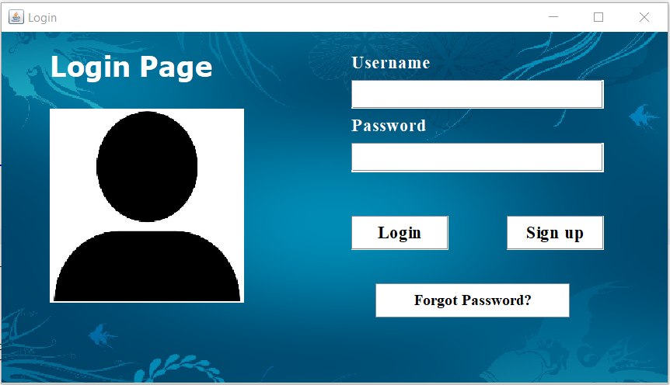

**LOADING PAGE:**

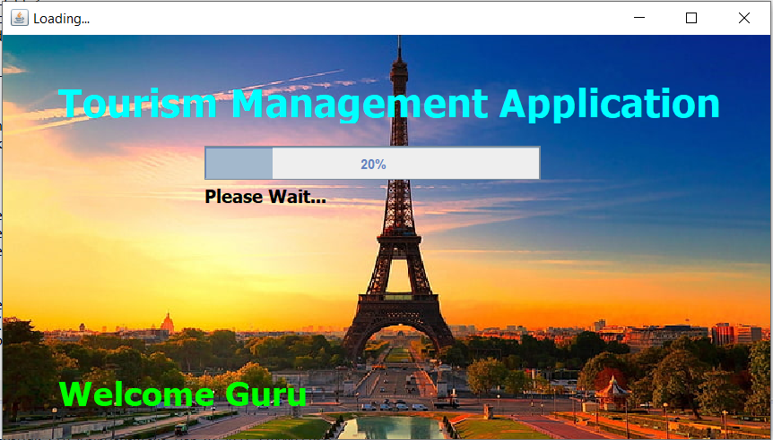

**MAIN FRAME:**

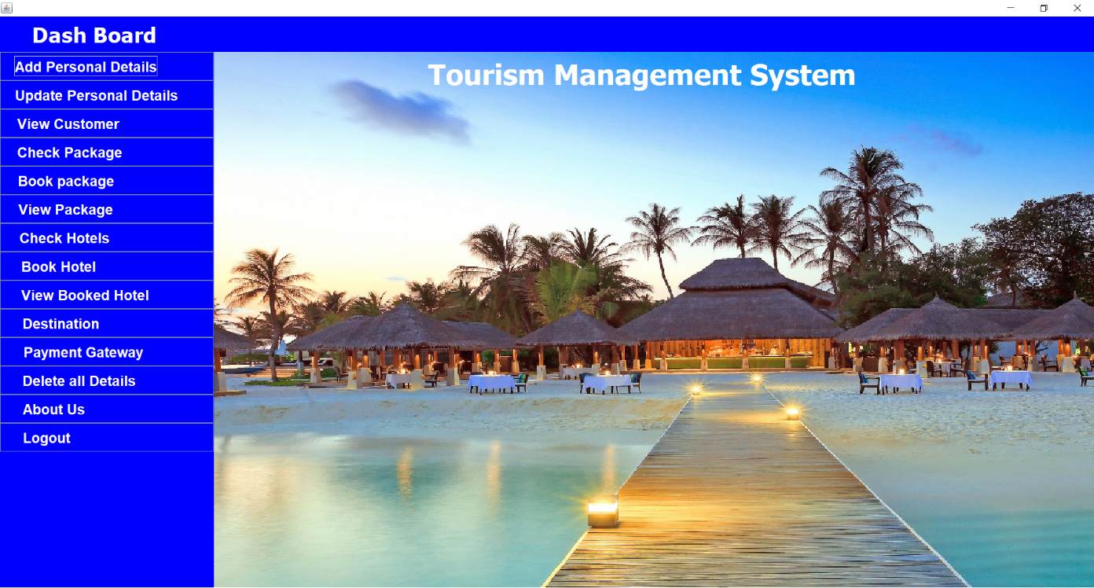

**PERSONAL DETAILS:**

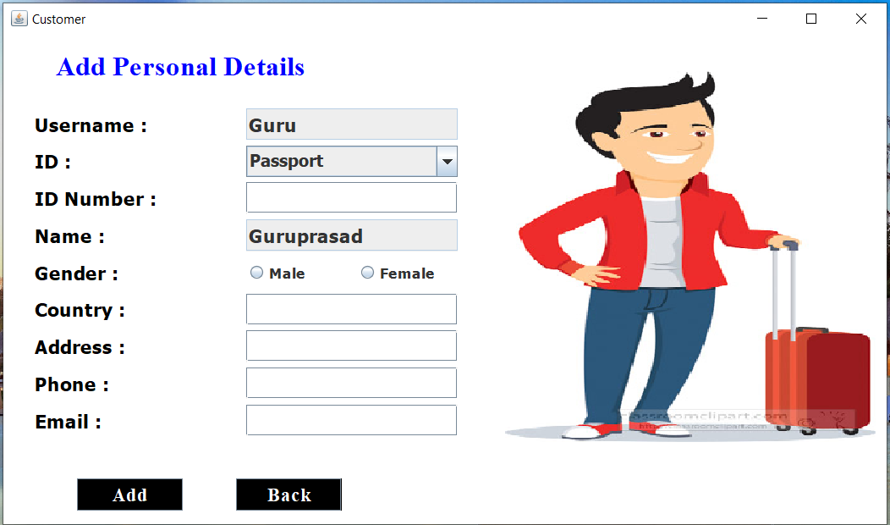

**UPDATE CUSTOMER PAGE:**

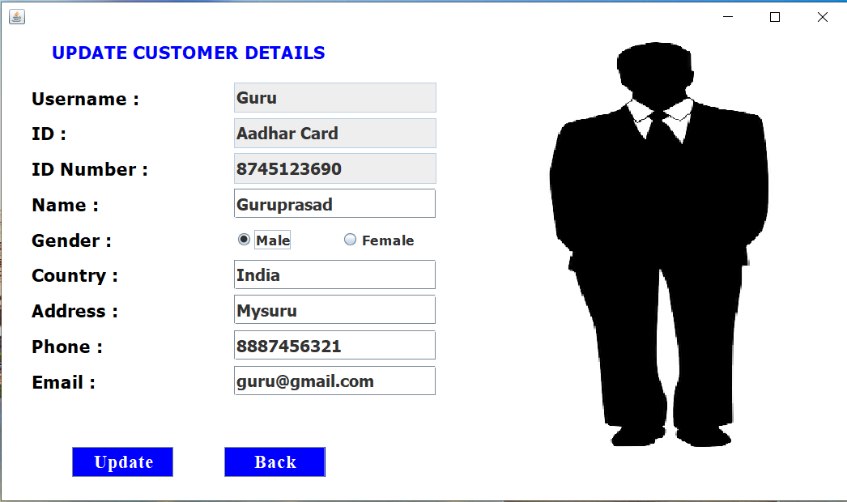

**VIEW CUSTOMER PAGE:**

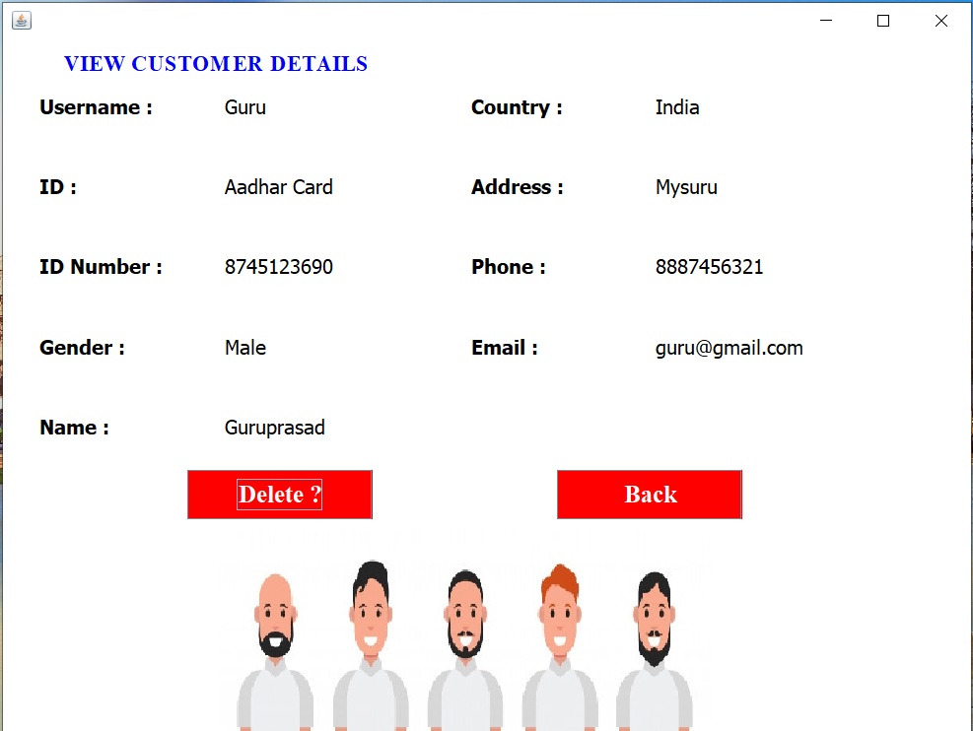

**PACKAGE PAGE:**

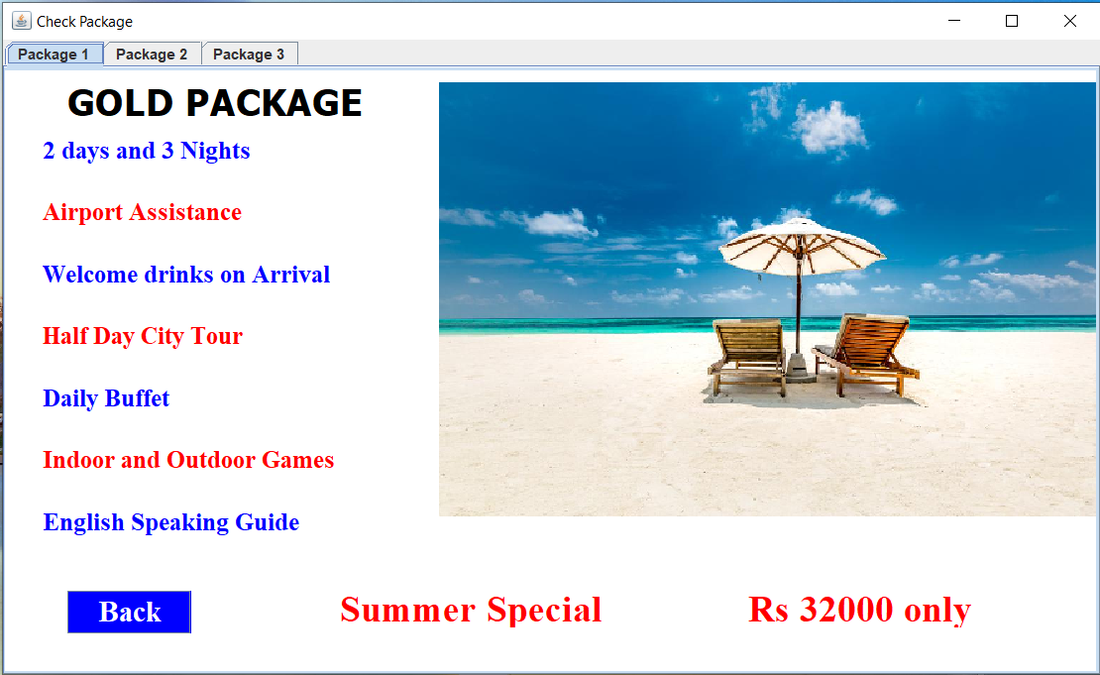

**BOOK PACKAGE:**

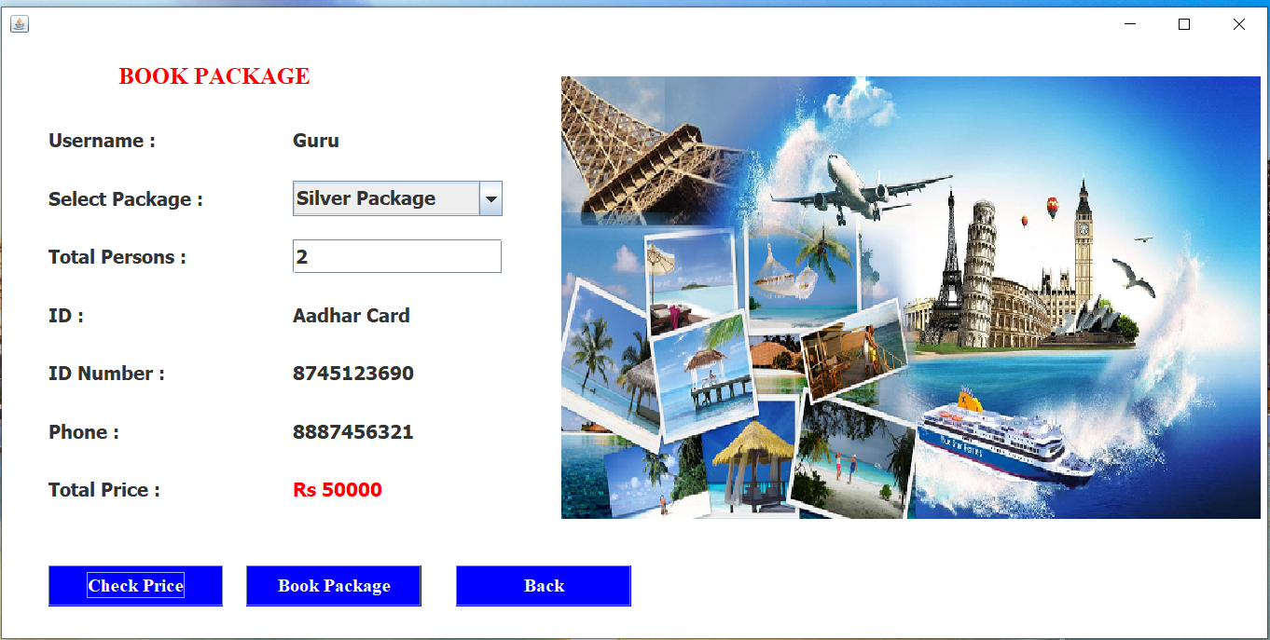

**VIEW PACKAGE:**

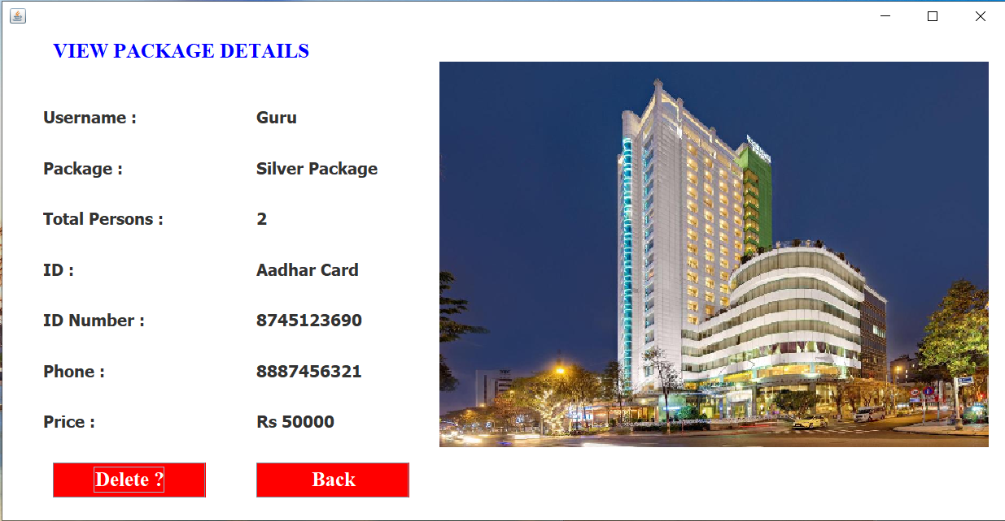

**HOTEL/RESORT PAGE:**

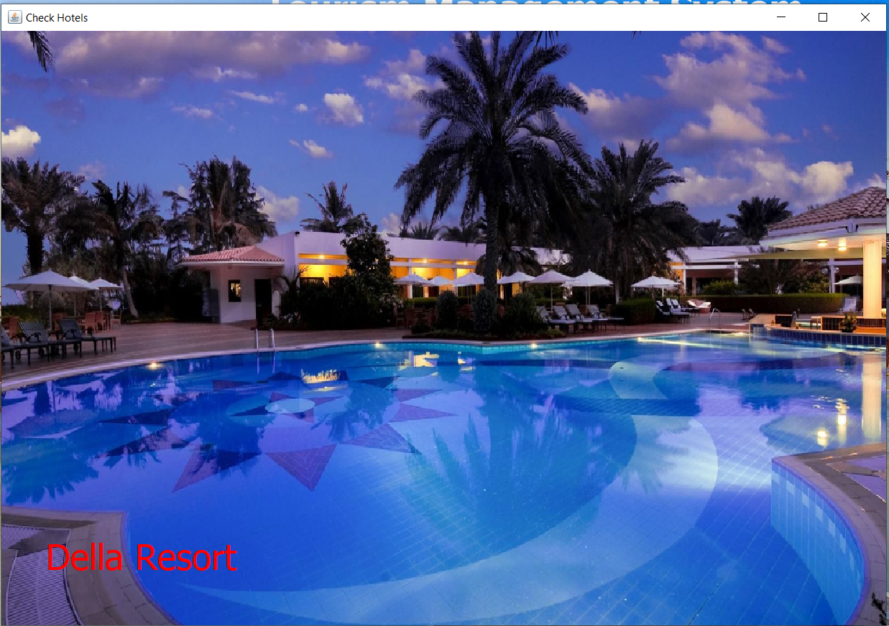

**BOOK HOTEL:**

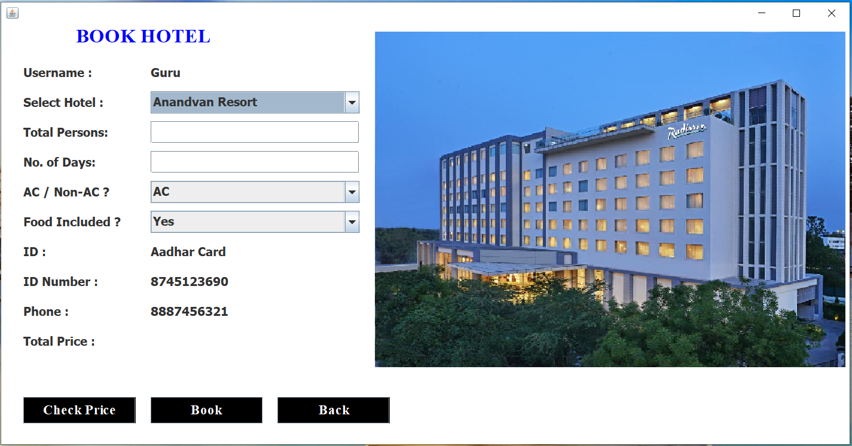

**VIEW HOTEL:**

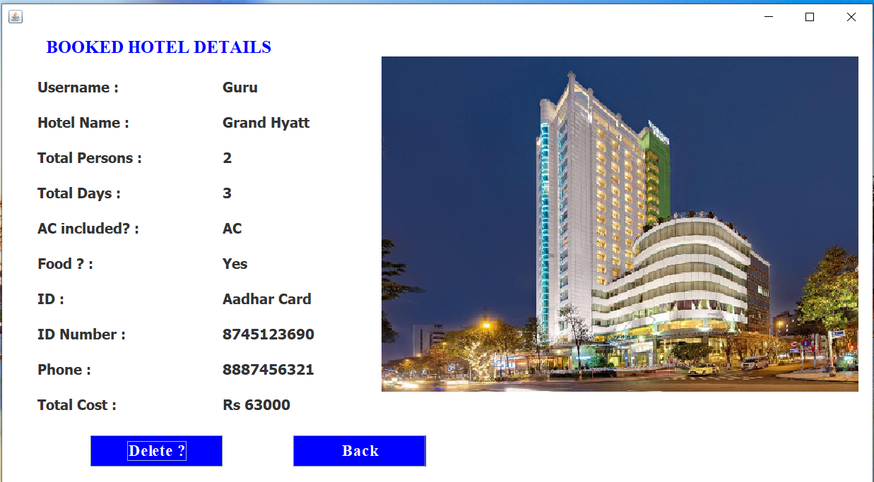

**DESTINATION PAGE:**

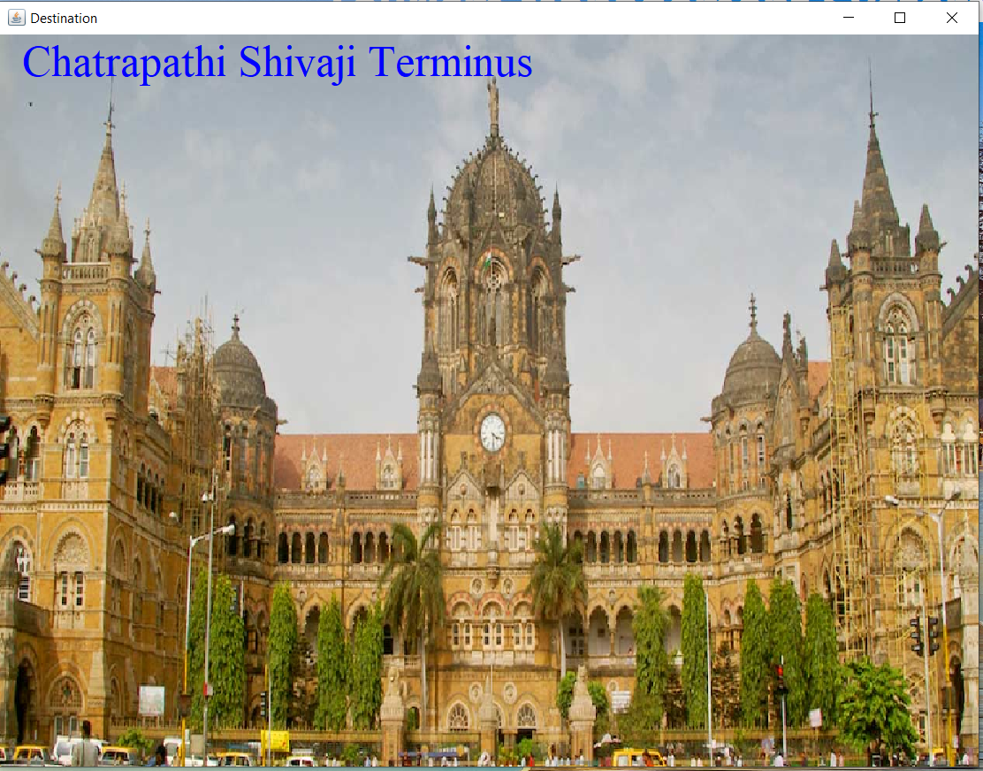

**PAYMENT:**

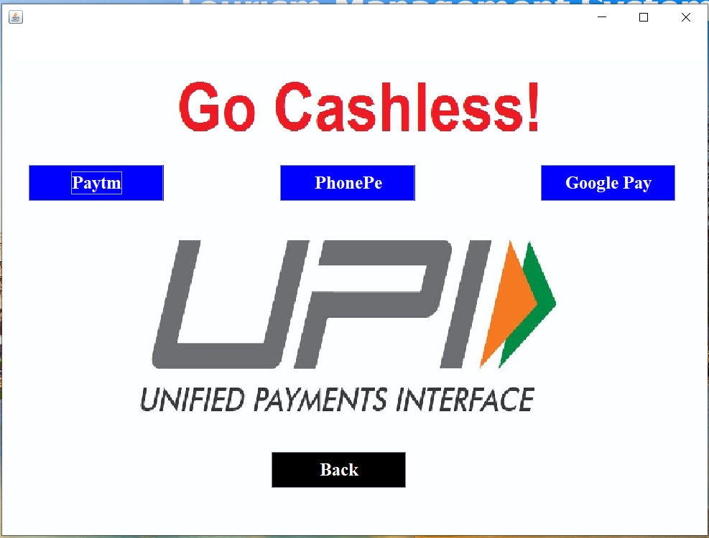

**DELETE ALL:**

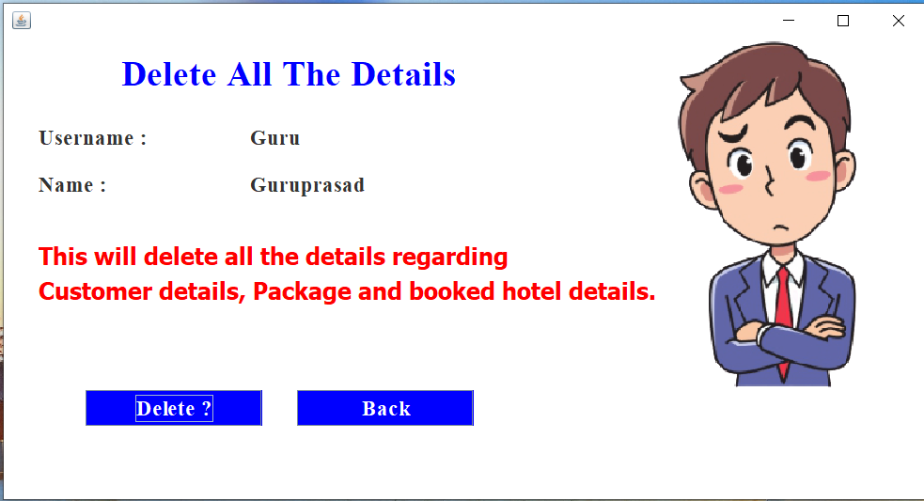

**ABOUT PAGE:**

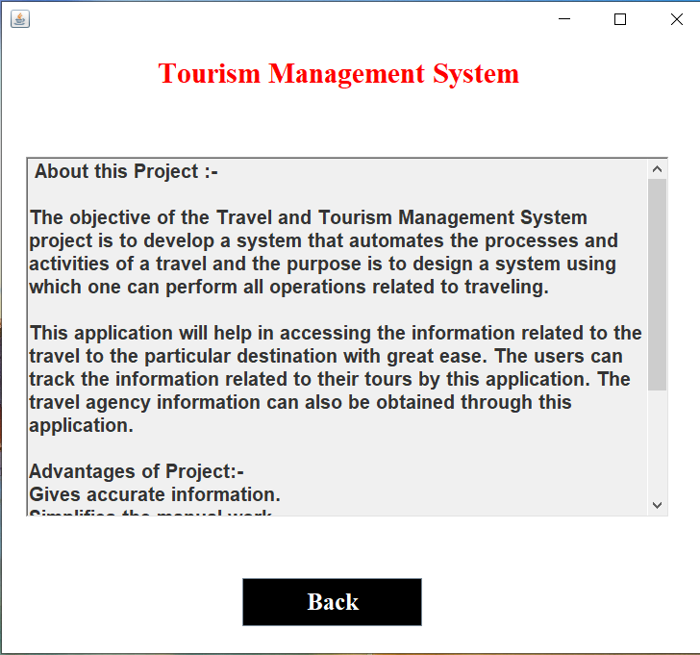

|  |  |
| --- | --- |
| **Chapter 7** | **Conclusion and Future Scope**  The process of the system we can consider here, can maintain the databases of the system. We can insert to the databases and retrieve all the information.  The main aim of this project is to help the tourists to manage their trip. It makes all operation of the tour company easy and accurate. The standalone platform makes tourism management easy by handling requests and providing servers for the customers located at different parts of the various cities.  Different modules have been incorporated in this project to handle different parts and sector of the tour management field. |

|  |  |  |
| --- | --- | --- |
|  |  |  |

**REFERENCES**

We have taken references from many resources like YouTube and many websites.

Websites:

* <https://www.w3schools.com>
* <https://www.javatpoint.com>
* <https://www.codecademy.com>
* <https://www.stackoverflow.com>

YouTube video links:

1. <https://youtu.be/5vzCjvUwMXg>
2. <https://youtu.be/dwVj_g3TpZ4>
3. <https://youtu.be/L5RpqspNAuc>